**AI LAB TASK 1**

**NAME: SYED MUZZAMIL WASEEM**

**SID: 11067**

**CID: 110089**

**CODE:**

import random  
class environment(object):  
 def __init__(self):  
 self.location={'Room A':'0','Room B':'0'}  
 self.location['Room A']=random.randint(0,1)  
 self.location['Room B'] = random.randint(0, 1)  
class vacuum(environment):  
 def __init__(self,environment):  
 print(environment.location)  
 counter=0  
 vacuumlocation=random.randint(0,1)  
 if vacuumlocation==0:  
 print("Vacuum is initially placed at Room A")  
 if environment.location['Room A']==1:  
 print("Room A is dirty")  
 environment.location['Room A']=0  
 print("Room A has been cleaned")  
  
 if environment.location['Room B'] == 1:  
 print("Room B is dirty")  
 print("Vacuum moving to Room B")  
 environment.location['Room B'] = 0  
 print("Room B has been cleaned")  
 else:  
 if environment.location['Room B']==1:  
 print("Room B is dirty")  
 counter-=1  
 print("Vacuum moving to to Room B")  
 environment.location['Room B']=0  
 counter+=1  
 print("Room B has been cleaned")  
 elif vacuumlocation==1:  
 print("Vacuum is initially placed at Room B")  
 if environment.location['Room B'] == 1:  
 print("Room B is dirty")  
 environment.location['Room B'] = 0  
 print("Room B has been cleaned")  
 if environment.location['Room A'] == 1:  
 print("Room A is dirty")  
 print("Vacuum moving to Room A")  
 counter -= 1  
 environment.location['Room A'] = 0  
 print("Room A has been cleaned")  
 else:  
 print("Vacuum moving to Room A")  
 counter -= 1  
 if environment.location['Room A'] == 1:  
 print("Room A is dirty")  
 environment.location['Room A'] = 0  
 print("Room A has been cleaned")  
 print(environment.location)  
env=environment()  
vac=vacuum(env)

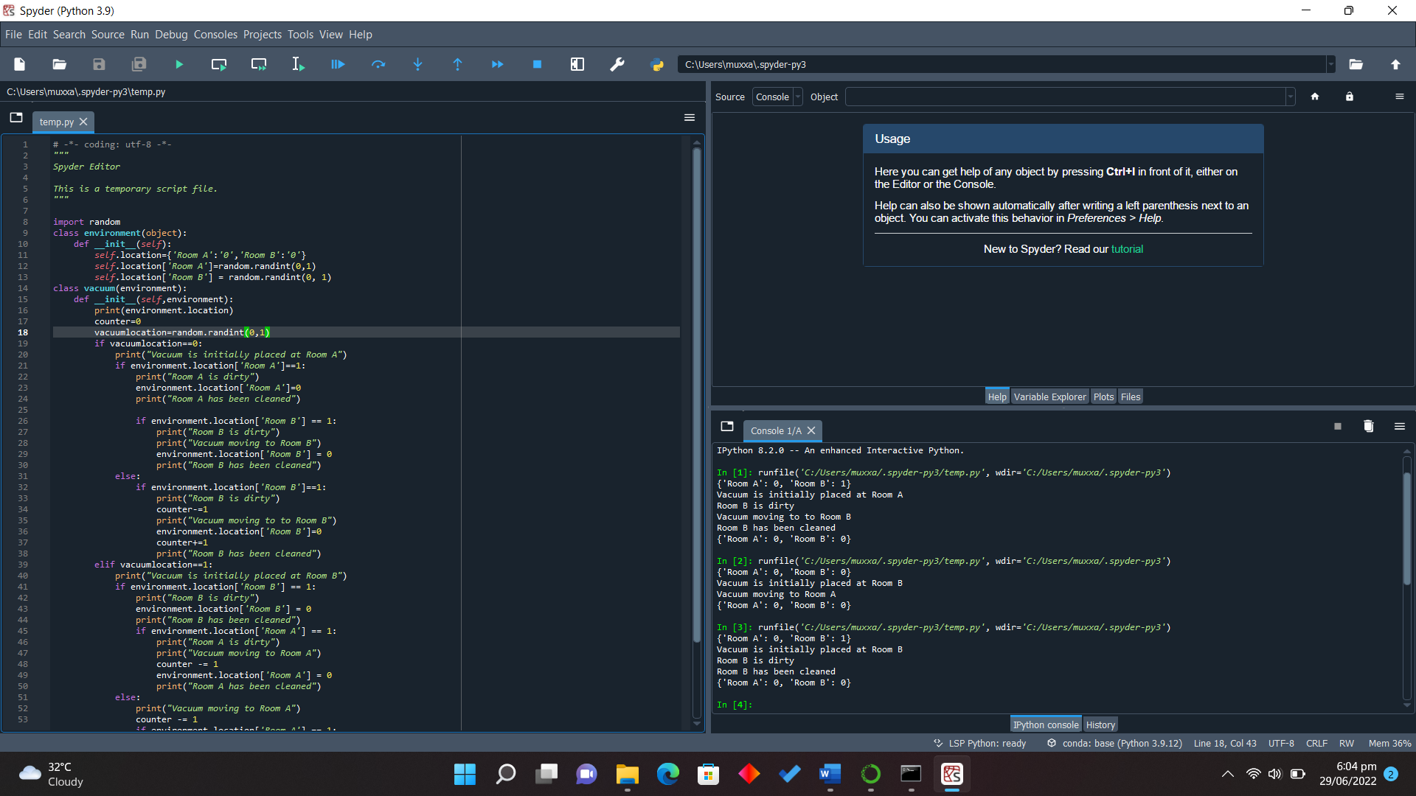  
 **SCREENSHOT:**